### **CURRICULUM VITAE**

### **Personal Information:**

### 

* 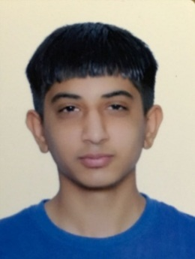**Name:** Ahmed haider ali matrook
* **Date of Birth**: 28/1/1999
* **Marital Status**: Single.
* **Contact Number:** 34414045 - 36661647
* **E-mail:** hamood_199928@hotmail.com
* **Address:** H100 R 3307 B 633, Ma'ameer, Bahrain
* **CPR:** 990110036

### **Education:**

### ]

* **General Secondary Certificate.**

### -Al Ta'awoon Secondary School

[2017]

### **Volunteer Participation:**

* **Scout in Local Association (Non-Profit Foundation)**

### **Computer Skills:**

* **Fast Typing Arabic & English**
* **Excellent at Microsoft application programs.**

Word, Excel, PowerPoint, Access

### **Skills:**

* **Communicate information and ideas clearly and concisely.**
* **Can work under pressure and have the ability to learn new things.**

### **Languages:**

1. **Arabic** (Mother Language) Excellent (speaking, writing & reading).
2. **English** (2nd Language) Good (speaking, writing & reading).

### **Key academy coursework :**

## Aptech (beginning English) 2018

## Aptech (spoken English)2018

**Available upon request.**